UNIANOVA sales BY compad promo
/METHOD=SSTYPE(3)
/INTERCEPT=INCLUDE
/PLOT=PROFILE(compad*promo)
/PRINT=DESCRIPTIVE
/CRITERIA=ALPHA(.05)
/DESIGN=compad promo compad*promo.

Univariate Analysis of Variance

Notes
Output Created |  | 26-MAR-2017 14:52:04
Comments
Input | Data | C:\Home\Work\GreatLakes\Advanced Stats\practice data\compad promo data anova.sav
Input | Active Dataset | DataSet3
Input | Filter | <none>
Input | Weight | <none>
Input | Split File | <none>
Input | N of Rows in Working Data File | 59
Missing Value Handling | Definition of Missing | User-defined missing values are treated as missing.
Missing Value Handling | Cases Used | Statistics are based on all cases with valid data for all variables in the model.
Syntax |  | UNIANOVA sales BY compad promo  /METHOD=SSTYPE(3)  /INTERCEPT=INCLUDE  /PLOT=PROFILE(compad*promo)  /PRINT=DESCRIPTIVE  /CRITERIA=ALPHA(.05)  /DESIGN=compad promo compad*promo.
Resources | Processor Time | 00:00:00.42
Resources | Elapsed Time | 00:00:00.35

[DataSet3] C:\Home\Work\GreatLakes\Advanced Stats\practice data\compad promo data anova.sav

Between-Subjects Factors
 |  | Value Label | N
Comparison Ad | -1 | No | 30
Comparison Ad | 1 | Yes | 29
Promotion | -1 | No | 30
Promotion | 1 | Yes | 29

Descriptive Statistics
Dependent Variable: Sales Per Day
Comparison Ad | Promotion | Mean | Std. Deviation | N
No | No | 7.94 | .680 | 16
No | Yes | 10.93 | 1.207 | 14
No | Total | 9.33 | 1.788 | 30
Yes | No | 11.21 | 1.718 | 14
Yes | Yes | 10.40 | 1.639 | 15
Yes | Total | 10.79 | 1.698 | 29
Total | No | 9.47 | 2.080 | 30
Total | Yes | 10.66 | 1.446 | 29
Total | Total | 10.05 | 1.879 | 59

Tests of Between-Subjects Effects
Dependent Variable: Sales Per Day
Source | Type III Sum of Squares | df | Mean Square | F | Sig.
Corrected Model | 103.024ª | 3 | 34.341 | 18.550 | .000
Intercept | 6023.955 | 1 | 6023.955 | 3253.851 | .000
compad | 27.765 | 1 | 27.765 | 14.997 | .000
promo | 17.419 | 1 | 17.419 | 9.409 | .003
compad * promo | 53.233 | 1 | 53.233 | 28.754 | .000
Error | 101.823 | 55 | 1.851
Total | 6165.000 | 59
Corrected Total | 204.847 | 58

a. R Squared = .503 (Adjusted R Squared = .476)

Profile Plots

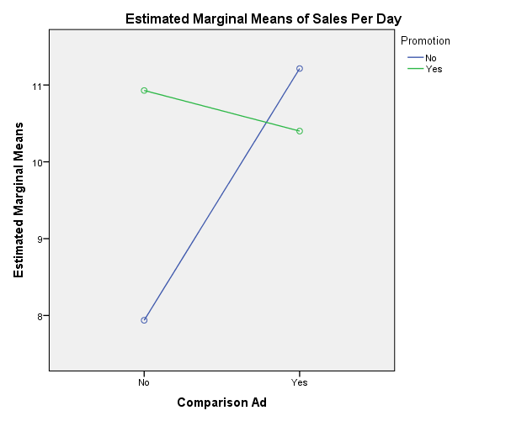

Promotion = Y and Ad = N : +ve
Promotion = N and Ad = Y : +ve

Promotion = Y and Ad = N : -ve
Promotion = N and Ad = N : -ve

So Interaction Effect is negative

